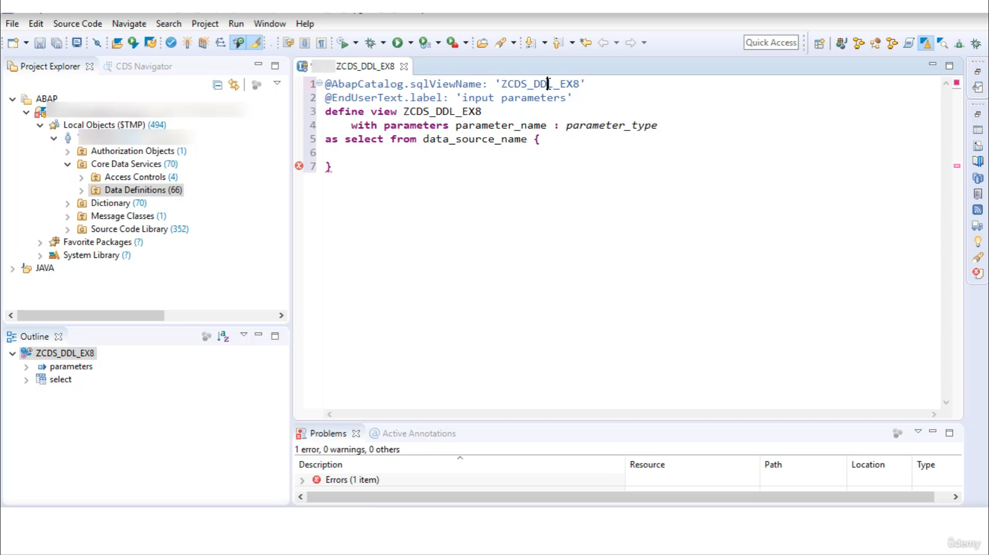

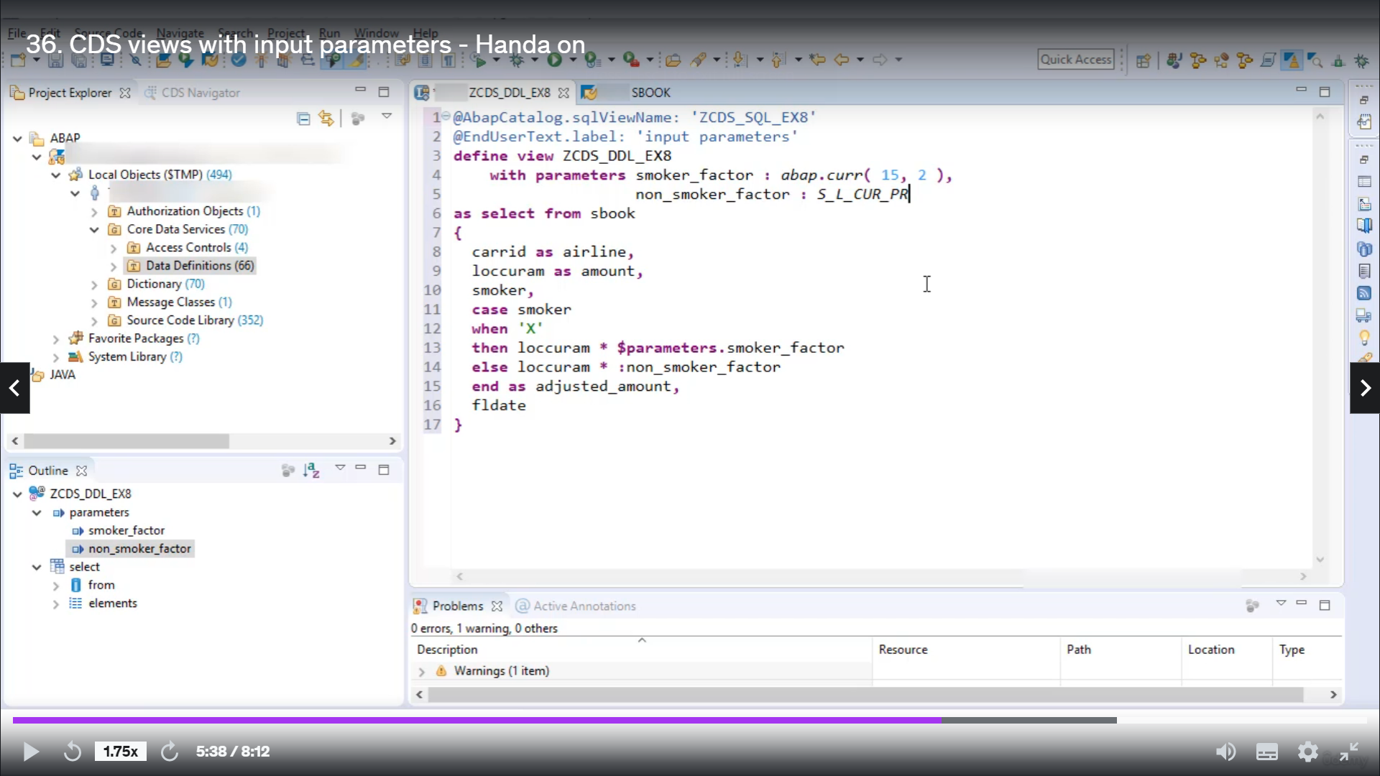

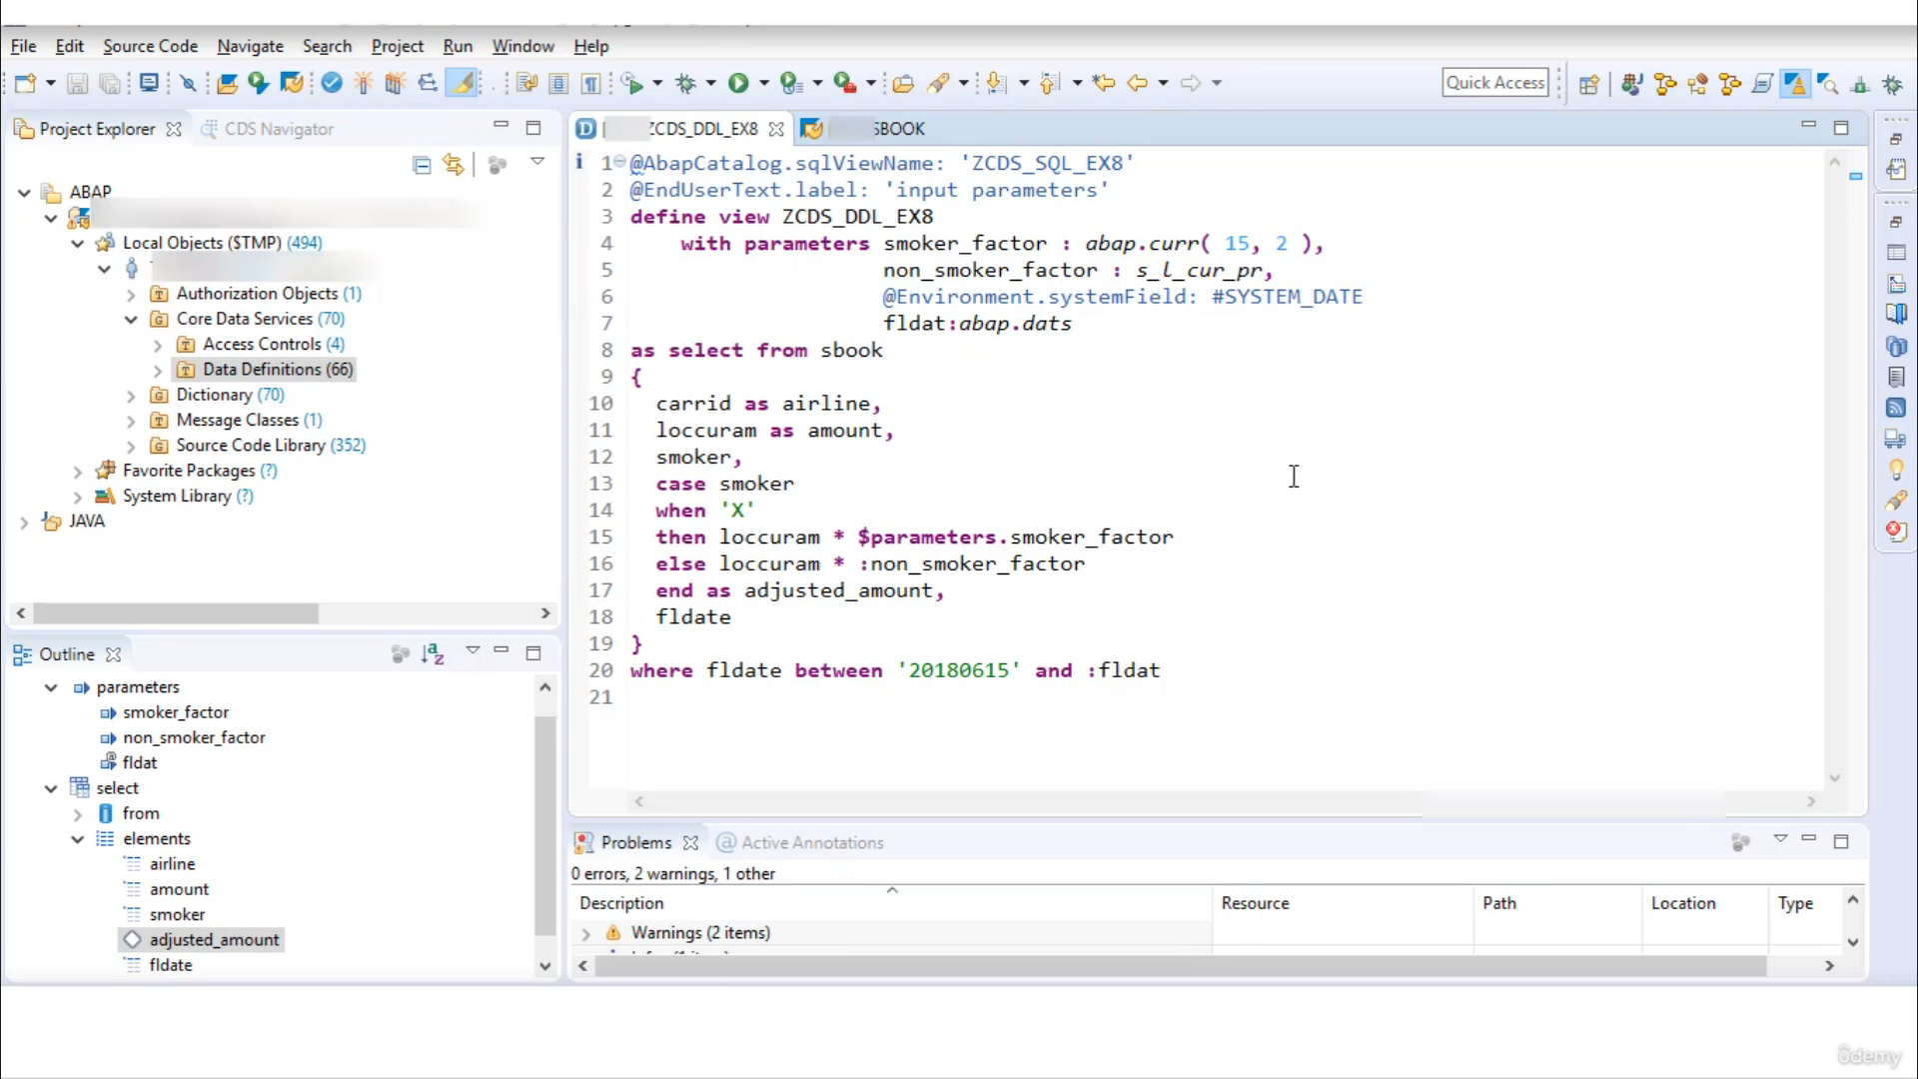

to pass system fields we have to add annotations

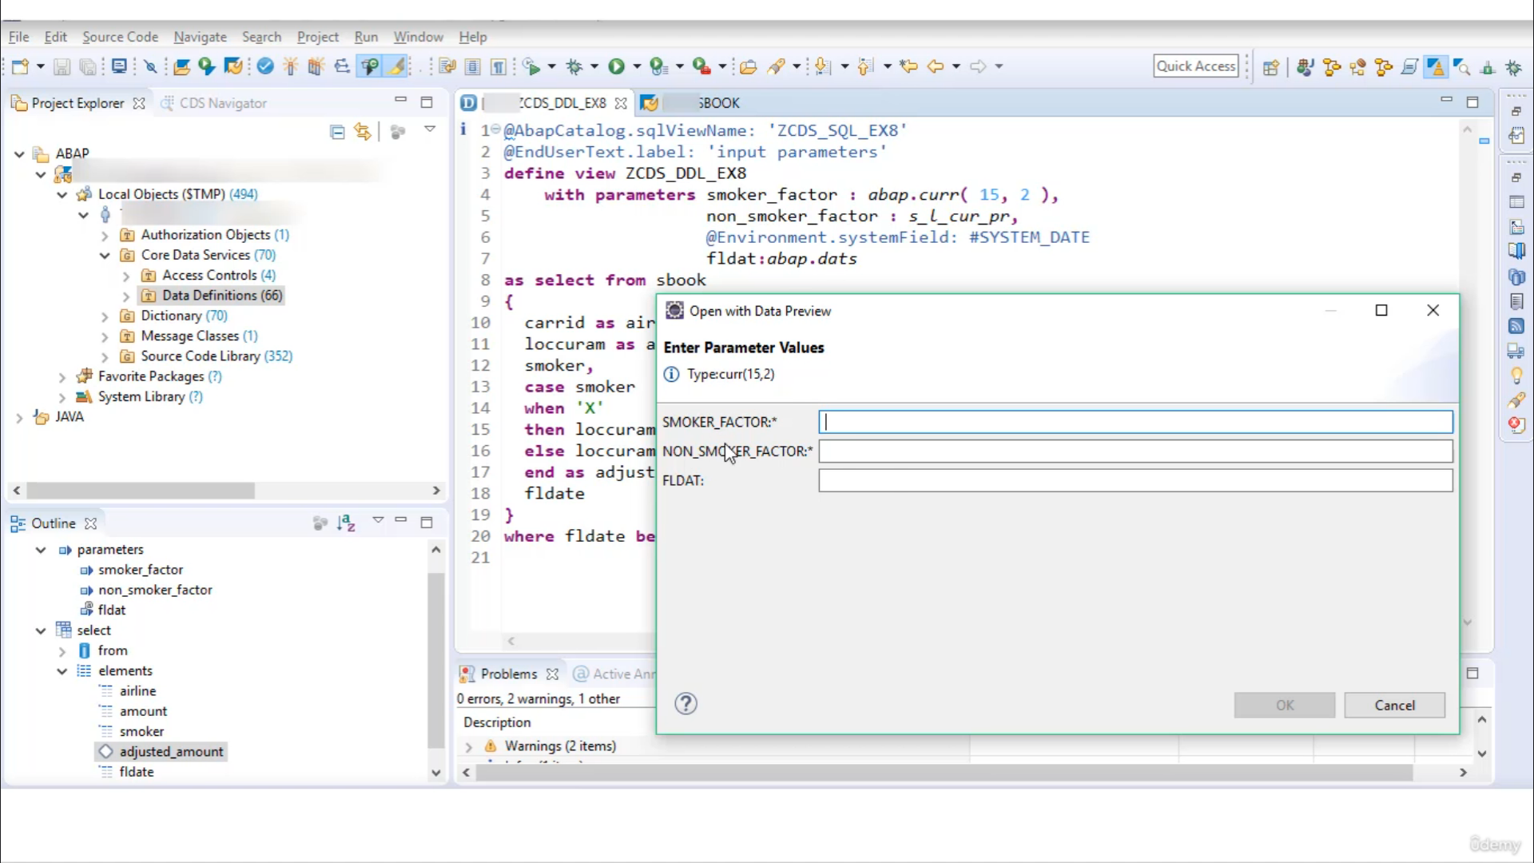

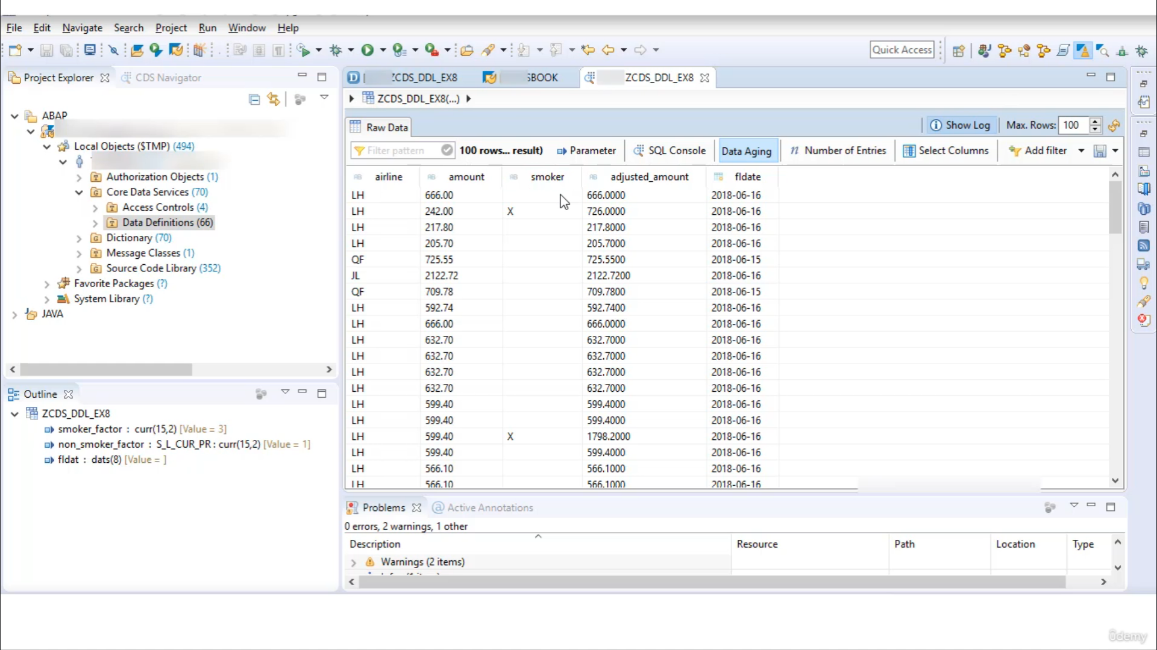

Looks great when I see this view with input parameter I'm giving them at Google example it description

as input barometer.

So here now we are to select a template defined with parameters.

So now let's do the basic setting.

We don't want this to annotations.

I remove it.

I will do that.

Is will rename it Gertrudis a scroll example eight.

OK, so now let's take one case where we want to charge customers differently, if the customer, the

smoker looking and what we get multiplied with some factor, if a customer is a non-smoker, then the

booking amount will get multiplied with some other factor.

And these two factors we will do as an input parameters.

OK, so, uh, first time you take some pills here from his book, you first feel that I want to take

this GARATY.

So you can feel that there won't be local currency among.

Taffin, a smoker.

And one more thing I want is flooded.

So now here we have the right gas explosion.

If the customary smoker, that means when the smoker is ex, the smoker will, it will characterful.

Then the local currency among

you could multiply with factor, uh, let's say smoker factor

ls the local currency amount will get multiplied.

Non-smoker factor.

So we have to end this gas explosion as.

I just stood among.

OK, so now here, these two are in good barometers, so we have to write these parameters here and

we don't need.

And here we are, great barometer tight, since we are multiplying these two factors with local currency.

Will take this factor of time as of local currency among to find out the type of this local currency

amount we are to go to table as book select is book in place of three.

OK, it's not working because of this error.

So for the time being, I'll comment on these two parameters and now I perfectly OK.

Now here you can see local currency mortgages is of the currency linked 15 decimal to.

So the debit here.

The smoker factories of type.

ABAB currency Leontes 15 and the decimal, sir, to.

OK, so here we have used an obligatory data for non-smoking factor will use the time name.

So this one.

I just wanted to show you, you can use Aboriginality today as a type of barometer or you can use that

name as a parent.

OK, then, uh.

OK, so let's see what are the rules colony is not known, OK?

The colony is the local currency.

OK, now just get rid of your derivatives column.

Smoker factor is not known, OK, since these were the input parameters, your prefix it with either

dollar better readers or with colon.

Not all errors are gone to demonstrate how we can use system for use as a barometer.

I will add here when Motorama didn't name the date and the type of this flight did very well.

There is other.

It's to pass this parameter system for you, you have to use annotation.

A direct involvement system, dog food and system did.

Now to restrict ResultSet avenues here very close.

The official date is between.

Let's take one fixed value, two thousand eighteen zero six 15, and the other parameter will be a folded.

OK, there is no error, so we can activate it.

And Ron.

So now you can see your system prompt us to enter the parameter values, smoker factor, non smoker

factor, flight data selects and the smoker factory's three non smoker factors one and the flight data.

So you can see these two factors are mandatory and this one is not mandated because even if you live

to plan, it will by default pass system did so.

Now click OK during the reason.

So you can see if the customer is non smoker, they are just the same as booking a and if the customary

smoker then is charge based.

OK, so that's it for now.

I hope you understood how you can use the input parameters.

Absolutely.

Thank you for watching with you.

Have a great day.